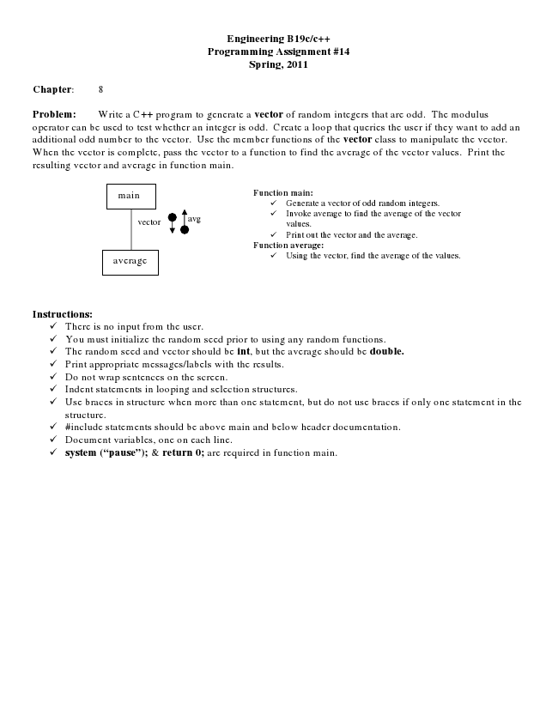

**Engineering B19c/c++ Programming Assignment #14 Spring, 2011**

**Chapter: 8**

Problem: Write a C++ program to generate a vector of random integers that are odd. The modulus operator can be used to test whether an integer is odd. Create a loop that queries the user if they want to add an additional odd number to the vector. Use the member functions of the vector class to manipulate the vector. When the vector is complete, pass the vector to a function to find the average of the vector values. Print the resulting vector and average in function main.

main

**Function main:**

✓ Generate a vector of odd random integers.

vector

avg

✓ Invoke average to find the average of the vector

values. ✓ Print out the vector and the average. Function average: average

✓ Using the vector, find the average of the values.

**Instructions:**

✓ There is no input from the user. ✓ You must initialize the random seed prior to using any random functions. ✓ The random seed and vector should be int, but the average should be double. ✓ Print appropriate messages/labels with the results. ✓ Do not wrap sentences on the screen. ✓ Indent statements in looping and selection structures. ✓ Use braces in structure when more than one statement, but do not use braces if only one statement in the

structure. ✓ #include statements should be above main and below header documentation. ✓ Document variables, one on each line. ✓ system (“pause”); & return 0; are required in function main.